The China Threat is Real for America
A Business Executives View and Perspective

“The greatest long-term threat to our nation’s information and intellectual property, and to our economic vitality, is the counterintelligence and economic espionage threat from China.”
FBI Director Christopher Wray

After nearly two years working for a Chinese owned company, it has become increasing clear that we are at war. It is a war that does not involve guns, bombs or troops invading. It is a systemic, methodical, and well-orchestrated war that is attacking us on multiple fronts all supported by a disinterested and selfish population:
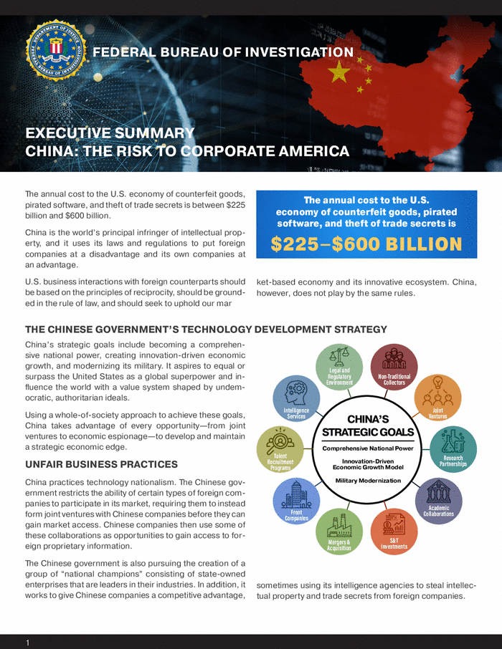
- Stealing critical manufacturing US jobs
- Stealing technology from companies and universities
- Buying US companies, real estate, and ranchland
- Infiltrating our Universities and our local and national government for theft and cultural manipulation
- Happily loaning us money as we pile on unsustainable debt
- Restricting our ability to import products to China
https://www.youtube.com/watch?v=GdapE82GceA&t=3s
The recent confirmation by the FBI that COVID was manmade combined with the Balloon fiasco brings this into public view. Unfortunately, these issues have been building for nearly twenty years and my recent personal experience just confirms what I have felt for years.

As I transition into retirement I can reflect on my career and speak freely without repercussions. As background for nearly forty years my career has taken me to Korea, Japan and China to take advantage of low costs for my employers, Fortune 500 companies as well as privately held businesses. For most of my professional career I viewed this as appropriate and required to remain competitive in a changing global economy. In many respects it was an eye opening and rewarding experience to visit these countries, learn their cultures and see the world. In my early years at GE, we were one of the first companies to bring the Toyota Manufacturing System to Louisville, Ky in the early nineties. This eventually led to trips to Korea to coordinate contract manufacturing work with a small company called Lucky Goldstar, now not so small LG. Over the years as my career advanced and I changed companies the work moved to China for low cost manufacturing and my first experience with job elimination by reducing or eliminating US manufacturing, this continued with several companies for the remained of my career.

This culminated in me being recruited as the Chief Operating Officer of a company that was purchased out of bankruptcy by a Chinese company. This job allowed me to move back to my home state and the attractions were a great brand and my being able to help a small town retain its manufacturing jobs which I felt would be a great way for me to end my career. I was excited for this to be a wonderful culmination to my career helping rebuild and retain jobs in small town America.
I was assured the new owner believed in US manufacturing and was committed to the small-town factory. These assurances came from both China management and an American CEO. It is now clear to me that none of this was true. The company was purchased during Covid, and incredible supply chain challenges from China. The Chinese owners never visited the business when they bought the assets out of bankruptcy. After eighteen months of rebuilding the culture and business timed with the relaxing of Covid it became clear that things were changing. Regular visitors from China, a lack of involvement from the American CEO and staff raised suspicions. After a few months of processing these behaviors and endless unusual and questionable requests without inclusion or discussion it became clear the US facility could not be sustainable with the slow removal of items from the factory. When I alerted the US CEO and his staff that the US facility could not survive with these products moving to China I was offered the opportunity to retire just hours later. I refused as it was obvious this was in the works already and I was no longer needed. I refused lie to the staff and required them to fire me and forced them to announce it and they did. Sixty days after my departure a WARN Notice was given to the employees announcing that all manufacturing was moving out of the factory to China and Vietnam.

I share my recent experience to provide a very real context but more importantly highlight a few concepts that are part of the bigger concern that I am highlighting:
- They are constantly observing and learning and use our open management approach against us
- A general lack of transparency and inclusion of US management in decision making
- Dishonesty
- They view workers as a commodity and disposable
- Arrogance relating to American workers and skills
- Inconsistent and unpredictable behavior
- China government subsidizing exports to artificially show lower costs
- Unwillingness to follow America regulations and laws – willingness to look the other way, claim ignorance or believe they won’t get caught.

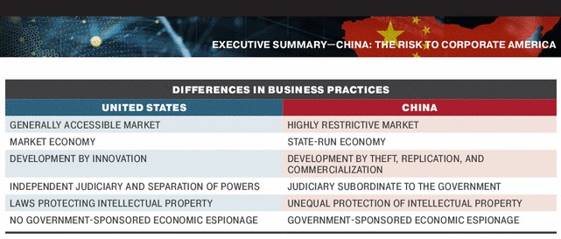

China 2025 and 2035

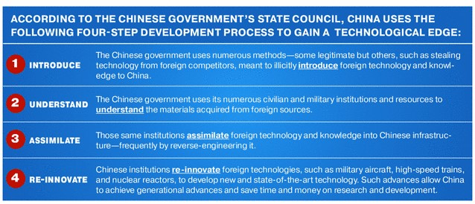

My hope is that by sharing my own experience and sharing some of these less widely known Government perspective reports I can improve the understanding of the threat and what’s at risk for our country. I am personally guilty of looking the other way as a consumer but also in my career, but ignorance is not a good justification. One of my great professional regrets is working for a Chinese company. Having said that I made a real connection to the people and the community that I was responsible for leading and I believe they know my intentions were honorable, but I am disappointed I couldn’t do more to preserve their jobs and help a small town in my home state.

I am better informed now, and my hope is that those that work for Chinese companies do some introspection and think twice about their career choice. What I learned is that no matter what the short-term benefits might be for you or the organization in the long run we are betraying our country, our culture and I believe by default jeopardizing our freedom! It will not happen tomorrow; it will not happen next year but my personal experience and research suggests that if we don’t fight back and stand up to this treat it will happen sooner than we think. We all make personal choices and I believe those that believe it’s someone else’s problem, I can’t do anything, I’m getting paid why do I care are taking the easy way out. That attitude in my opinion represents the deterioration of America and what made us different. We are not perfect, we have lots to fix but our country has always stood for a chance, choice, and fairness. What we are dealing with now is not a fair fight! This is a complex topic and China and America, and the world are so entangled it will take very focused, smart, and patriotic leadership to navigate this. What I am certain of is that if we stay on the current course we will lose America and freedom because the Communist party of China is on a mission and technology is their friend making it easier and easier to infiltrate, destroy and control.

I hope my perspective resonates with you as I believe we still have a chance to preserve our great experiment!

Charlie Lawrence
Concerned Citizen and Patriot

